**Managing a Computing Project**

**030202190**

**H/618/7407**

**Section (4)**

Helping the environment

**Submitted To:**

Dr. Nayef Abuageel

**Submitted By:**

Farouq Hassan

Fall 2022

**Table Of Contents**

**Part 1**

1.1. Functional and non- Functional requirements………………. (4)

1.2. Priority requirements and Goal metrics………….………… (5)

1.3.In scope and out of scope ……………………….……... (8)

1.4. the Objectives …………………….……………….………………… (8)

1.5. Milestone…………………….………………………… (9)

1.6. Cost Management Plan.………………………… (10)

1.7. Time Management Plan.………………………… (11)

1.7. The critical path for the project…………………………… (12)

1.8. Change management Plan…………….………………………….…… (15)

1.8.1 …………………….………………………… (15)

1.8.2 …………………….………………………… (16)

1.8.3 …………………….………………………… (17)

1.8.4. …….……………………………….….………………………… (17)

1.9. Risk management plan …….…………………….………………………… (19)

1.10. Software development methodology ……….………………………… (22)

**------------------------------------------------------------------------------**

**Part 2**

2.0. Project Recommendations and Justifications ……………… (23)

2.1. …….…………………….………………………… (24)

2.2. …………………….………………………… (25)

2.3. …….…………………….………………………… (25)

2.4. …….…………………….………………………… (26)

**------------------------------------------------------------------------------**

**Part 3**

3.0. Performance Review

3.1. ………………………………………. (27)

3.2. ………………………………….….……... (28)

**------------------------------------------------------------------------------**

|  |  |  |
| --- | --- | --- |
| **Functional requirements** | * The ability to repair and recycle devices instead of buying new ones. * The ability to change parts and use used parts to extend the life of devices. * The ability to sell parts to factories for reuse in other industries. * The ability to track and monitor the environmental impact of recycling and repairs within the company. * The ability to provide training sessions for employees on the environmental benefits of recycling and reducing carbon footprint. * The ability to hire part-time employees to assist with recycling and repairs. * The ability to establish partnerships with other companies or organizations to promote recycling and sustainability. * The ability to identify and purchase refurbished devices for use in the company. * The ability to track the lifespan and usage of devices to determine when they should be recycled or replaced. * The ability to provide incentives for employees who use recycled devices or participate in recycling Program. | |
| **Non-functional requirements** | * The system shall be easy to use and understand for employees. * The system shall be user-friendly, with a simple and intuitive interface. * The system shall be cost-effective and not require a large budget. * The system shall be flexible to allow for changes and adjustments as needed. * The system shall be secure and protect employee data. * The system shall be scalable and able to accommodate future growth. * The system shall be environmentally friendly and align with the company's sustainability goals. * The system shall be able to generate reports and analytics to track progress and measure success. * The system shall be compliant with relevant laws and regulations. * The system shall have a high level of accessibility, allowing employees to access it from various devices and locations. * The system shall be able to integrate with other software and procedures currently in use by the company. * The system shall be sustainable and use minimal resources to operate. | |
| **Priority requirements** | * The ability to repair and recycle devices instead of buying new ones. * The ability to track and monitor the environmental impact of recycling and repairs within the company. * The ability to provide training sessions for employees on the environmental benefits of recycling and reducing carbon footprint. * The ability to track the lifespan and usage of devices to determine when they should be recycled or replaced. * The system shall be easy to use and understand for employees. * The system shall be environmentally friendly and align with the company's sustainability goals. * The system shall be able to generate reports and analytics to track progress and measure success. * The system shall be sustainable and use minimal resources to operate. | |
| **Goal metrics** | | |
| User engagement | Goal: Goal: Increase user engagement in the recycling program by 50% within the next year. | Actual: At the end of the next year, user engagement in the recycling program has increased by 50% (measured by tracking the number of users actively participating in the program) through the implementation of incentives and training sessions (measured by tracking the number of incentives and training sessions provided). |
| User adoption | Goal: Goal: Increase user adoption of refurbished devices by 75% within the next year. | Actual: At the end of the next year, user adoption of refurbished devices has increased by 75% (measured by tracking the number of users using refurbished devices) through the implementation of education and awareness campaigns (measured by tracking the number of education and awareness campaigns conducted). |
| Technical issues/defects | Goal: Goal: Reduce the number of technical issues/defects by 50% within the next year. | Actual: At the end of the next year, the number of technical issues/defects has been reduced by 50% (measured by tracking the number of technical issues/defects |
| % Of features delivered/released | Goal: Goal: Deliver at least 80% of the planned features within the next 6 months. | Actual: At the end of the next 6 months, at least 80% of the planned features have been delivered (measured by tracking the percentage of features delivered compared to the total number of planned features) through the implementation of a project management system and regular progress reviews (measured by tracking the number of project management system usage and progress reviews conducted). |
| Reduce the company's carbon footprint | Goal: Goal: Reduce the company's carbon footprint by 37% within the next year by repairing and recycling devices. | Actual: At the end of the next year, the company's carbon footprint has been reduced by 37% (measured by tracking the company's carbon footprint before and after the implementation of the recycling program) through the repair and recycling of devices (measured by tracking the number of devices repaired and recycled). |
| Increase the number of employees who are using refurbished devices | Goal: Goal: Increase the number of employees who are using refurbished devices by 50% within the next year. | Actual: At the end of the next year, the number of employees using refurbished devices has increased by 50% (measured by tracking the number of employees using refurbished devices before and after the implementation of the program). |
| Sell a minimum of 10,000 parts to factories | Goal: Sell a minimum of 10,000 parts to factories within the next year. | Actual: At the end of the next year, a minimum of 10,000 parts have been sold to factories (measured by tracking the number of parts sold to factories). |
| Increase employee awareness and participation in recycling Program | Goal: Increase employee awareness and participation in recycling Program by 75% within the next year. | Actual: At the end of the next year, employee awareness and participation in recycling Program has increased by 75% (measured by conducting surveys before and after the implementation of the program). |
| Reduce the company's overall electronic waste | Goal: Reduce the company's overall electronic waste by 50% within the next year. | Actual: At the end of the next year, the company's overall electronic waste has been reduced by 50% (measured by tracking the amount of electronic waste generated by the company before and after the implementation of the recycling program). |
| Increase the overall lifespan of devices used by employees | Goal: Increase the overall lifespan of devices used by employees by 25% within the next year. | Actual: At the end of the next year, the overall lifespan of devices used by employees has increased by 25% (measured by tracking the average lifespan of devices before and after the implementation of the recycling program) through repairs and recycling (measured by tracking the number of devices repaired and recycled). |
| Reduce the cost of electronic devices | Goal: Reduce the cost of electronic devices by 30% within the next year through the use of refurbished devices. | Actual: At the end of the next year, the cost of electronic devices has been reduced by 30% (measured by comparing the cost of new devices to refurbished devices) through the use of refurbished devices (measured by tracking the number of refurbished devices purchased). |
| Increase employee satisfaction with the recycling program | Goal: Increase employee satisfaction with the recycling program by 80% within the next year. | Actual: At the end of the next year, employee satisfaction with the recycling program has increased by 80% (measured by conducting surveys before and after the implementation of the program). |
| Implement a comprehensive recycling program that includes all electronic devices used by the company | Goal: Implement a comprehensive recycling program that includes all electronic devices used by the company within the next 6 months. | Actual: Within 6 months, a comprehensive recycling program has been implemented (measured by tracking the number of electronic devices covered by the program) that includes all electronic devices used by the company (measured by tracking the percentage of devices covered by the program). |
| Develop a system that allows for easy tracking of devices and parts for recycling | Goal: Develop a system that allows for easy tracking of devices and parts for recycling within the next 3 months. | Actual: Within 3 months, a system for easy tracking of devices and parts for recycling (measured by conducting user testing and evaluating ease of use) has been developed and implemented (measured by tracking the number of devices and parts tracked by the system). |

**In scope and out of scope**

|  |  |
| --- | --- |
| In scpoe | Out Scope |
| Developing a comprehensive recycling program | Procurement of new hardware or equipment |
| Developing a system for tracking devices and parts for recycling | Implementation of the recycling Program in one location or facilities |
| Implementing the recycling program and tracking system | Costs associated with obtaining necessary permits or certifications for the recycling program |
| Monitoring the recycling program and tracking system | Obtaining funding for the recycling program from external sources |
| Setting up an inventory system for tracking recycled devices and parts | Any additional services or support not specifically outlined in the project scope. |
| Selling parts to factories |  |
| Evaluating and improving the recycling program |  |
| Providing training to employees on recycling Program and refurbished devices |  |

**The objectives**

1. Increase the recycling rate of devices and parts to reduce the environmental impact
2. Increases the use of refurbished devices in the organization.
3. Develop a recycling program that effectively tracks devices and parts for recycling.
4. Implement a system for tracking devices and parts for recycling.
5. Sell parts to factories to reduce waste and promote sustainable practices.
6. Continuously evaluate and improve the recycling program to ensure its effectiveness.
7. Provide training to employees on recycling Program and refurbished devices to increase user adoption and understanding.
8. Monitor the recycling program and tracking system to ensure it is functioning as intended.
9. Create a report on the recycling program's impact on the environment.
10. Develop software to support the recycling program and tracking system.
11. Test and ensure the quality of the recycling program and software.
12. Deploy the recycling program and software to all employees.
13. Provide ongoing maintenance and support for the recycling program and software.
14. Establish a budget and reserve funds for potential unforeseen expenses.
15. Reduce carbon footprint Decrease environmental impact, meet sustainability goals Percentage reduction in carbon footprint by 37% by the end of the year
16. Improve device recycling Extend device lifespan, save cost on purchasing new devices, meet sustainability goals Percentage of devices recycled or repaired by 30% by the end of the year 35% at the end of the year
17. Increase employee participation in recycling program Promote environmental consciousness among employees, increase cost savings Percentage of employees participating in recycling program by 70% by the end of the year
18. Establish partnerships with other companies or organizations to Promote recycling and sustainability on a larger scale, and increase cost savings Number of partnerships established 2 at least
19. Implement an inventory system for tracking recycled devices and parts to Increase transparency and accountability, and improve the efficiency Accuracy, and completeness of inventory data
20. Provide training sessions for employees on recycling and reducing carbon footprint Promote environmental consciousness among employees, and increase employee engagement Number of employees trained, satisfaction survey results by 40%in by the end of the year

**Milestone**

|  |  |  |
| --- | --- | --- |
| Date | Milestone | Description |
| 25/1 | Design completion | With the completion of this milestone, the design phase of the project is complete. During this phase, the system's general appearance and feel are decided upon, and the user interface is created. As it lays the groundwork for the remainder of the project, this crucial milestone is important. |
| 3/3 | Coding completion | This milestone marks the end of the coding phase, where the system is developed and coded. This is a crucial milestone as it lays the foundation for the rest of the project. |
| 19/4 | Deployment (all employees) completion | This milestone marks the completion of the deployment process for the system. This is an important milestone as it ensures that the system is accessible to all employees and that the company can begin to utilize the system. |
| 9/5 | Comprehensive recycling program development completion | This milestone marks the completion of the development of the recycling program. This is a critical milestone as it ensures that the program is in place and ready to be implemented. |
| 1/6 | Implementation of the recycling program and tracking system | This milestone marks the completion of the implementation of the recycling program and tracking system. This is a crucial milestone as it ensures that the system is in place and ready to be used by the company. |
| 19/6 | Trainees' and preparation | This milestone marks the end of the preparation of trainees. This is the process of identifying the individuals who will be trained on the project and preparing them for training. This milestone is important because it is a key step in ensuring that all employees are able to use the project effectively. |

**Cost Management Plan**

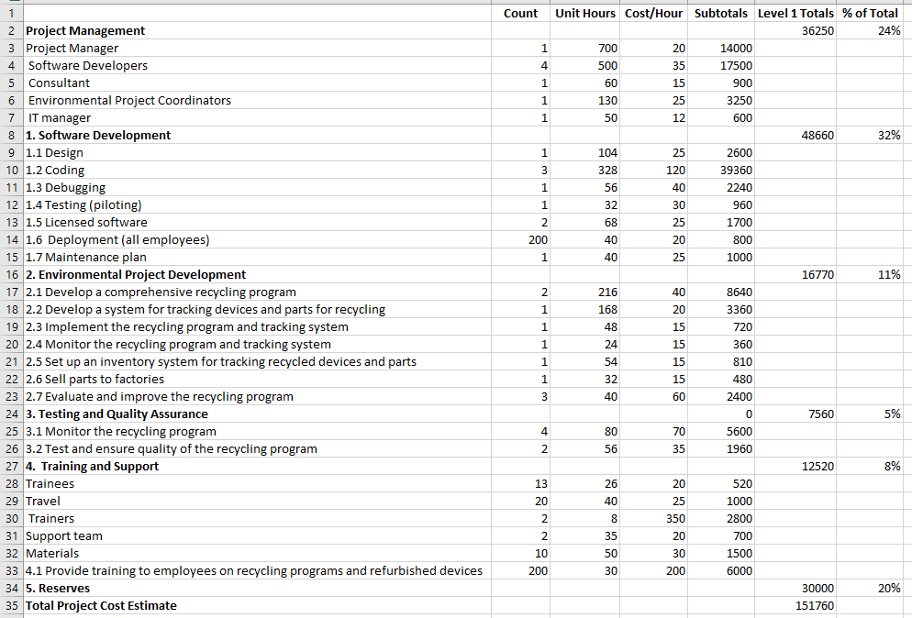

**Time Management Plan**

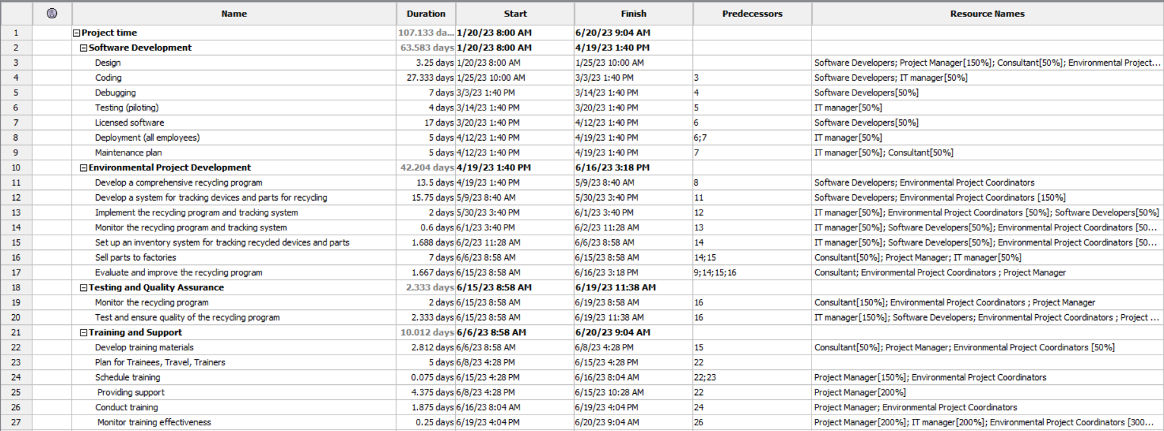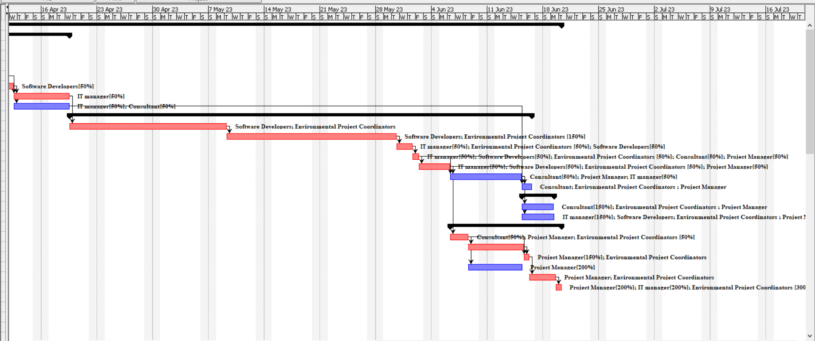

**The critical path for the project**

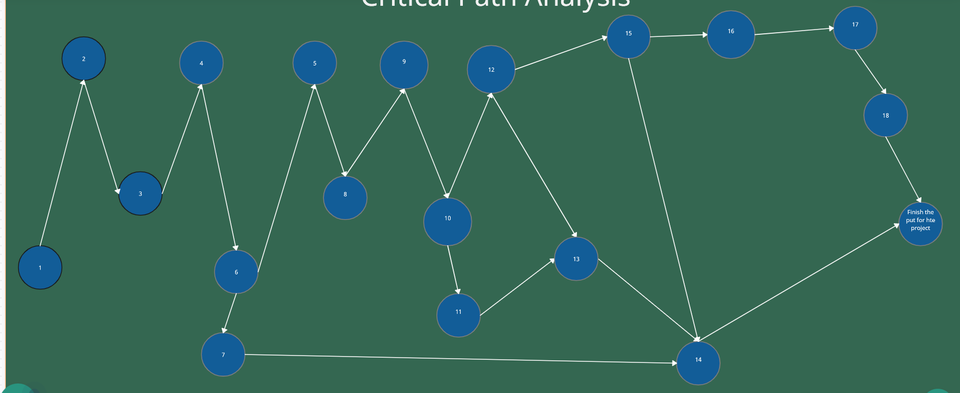

H=5

I=14

F=17

T=6

P=1

Y=3

L=2

D=4

C=7

B=28

A=4

E=5

K=2

J=16

V=7

M=2

N=1

R=2

G=5

S=5

O=2

Q=5

A+B+C+D+E+H+I+J+K+L+Y+P+T+Q=102

It’s the longest path so it’s the Critical path for the project and that means any delay on it the whole project will be delayed, and the other tasks will not effect on the time line for it

1 Design

2 Coding

3 Debugging

4 Testing (piloting)

5 Deployment (all employees)

6 Licensed software

7 Maintenance plan

8 Develop a comprehensive recycling program.

9 Develop a system for tracking devices and parts for recycling.

10 Implement the recycling program and tracking system.

11 Monitor the recycling program and tracking system.

12 Set up an inventory system for tracking recycled devices and parts.

13 Sell parts to factories

14 Evaluate and improve the recycling program.

15 Testing and Quality Assurance

16 Develop training materials.

17 Schedule training

18 Conduct training

This critical path in this project is important because it represents the sequence of tasks that must be completed on time in order for the entire project to be completed on schedule. These tasks are critical because they form the backbone of the project and without their completion, the project would not be able to move forward.

Additionally, identifying the critical path allows project managers to focus their efforts and resources on the most important tasks, guaranteeing that the project stays on schedule. Project managers are also able to foresee and deal with anticipated delays, enabling them to take remedial action before the delays become serious.

Because of this, completing these tasks by the deadline is crucial to the project's success, and any delays in these tasks would probably cause timetable delays for the entire project.

The others are important as well, but they are not critical path tasks. These tasks can be completed after the critical path tasks are done without affecting the project deadline.

to guarantee that there will be no delay on any of the critical path tasks, my approach would include the following procedures:

Clearly defining and communicating the critical path tasks to the project team. This includes outlining the dependencies between tasks and identifying the tasks that must be completed on time for the project to stay on schedule.

Establishing a system of regular progress updates and status meetings. This allows the team to stay informed of the progress of critical path tasks and identify any potential delays early on.

Implementing a robust project management system that allows for real-time tracking of task progress and resource allocation. This helps the team to stay on top of the critical path tasks and make adjustments as needed to keep the project on schedule.

Providing the necessary resources and support to the team members responsible for critical path tasks. This includes providing the team with the necessary training, tools, and support to complete their tasks on time.

Managing and mitigating risks associated with critical path tasks. This includes identifying potential risks, developing mitigation strategies, and taking action to minimize the potential impact of risks on the project schedule.

Establishing clear communication channels and protocols for reporting issues and delays. This allows for quick identification and resolution of any problems that may arise during the critical path tasks.

Continuously monitor and assess the progress of critical path tasks and adjust as needed to keep the project on schedule.

Using agile methodologies for project management since it helps to identify and resolve issues in a more efficient way.

Having a contingency plan in case of any unforeseen delays or issues that may arise during critical path tasks.

Encouraging teamwork, collaboration, and open communication to ensure that all team members are aware of the project's critical path tasks and are working together to keep the project on schedule.

**Change management Plan**

**1-**

In this project, the individuals and teams that will be impacted by the change include the project team members responsible for designing, coding, debugging, testing, and deploying the recycling program and tracking system. Additionally, all employees in the organization will be affected by the change as they will need to be trained on the new recycling program and tracking system and will be expected to use it on a daily basis.

The systems, processes, and policies that will be affected by the change:

1. The recycling program and tracking system will need to be implemented, which may require updates to existing systems and processes for waste management and disposal, Additionally, new systems and processes will need to be put in place to track and manage the flow of recycled materials.
2. Employee training on the recycling program and refurbished devices will be necessary, To ensure that all employees are aware of the new recycling program and are able to properly use the tracking system, which may require updates to current training materials and processes.
3. Software and IT systems: Changes to the recycling program may also require updates to existing software systems and IT infrastructure, to ensure proper tracking and reporting of recycled materials.
4. Any relevant external regulations regarding recycling and waste management will need to be adhered to, which will need to be reviewed and updated as necessary.
5. The inventory system for tracking recycled devices and parts will need to be set up, which may require updates to current inventory management systems and processes.
6. Changes to the procurement process for licensed software may be necessary to ensure compliance with the recycling program.
7. The maintenance plan for the organization's devices will need to be updated to align with the recycling program.
8. The organization's policies for data security and data destruction may need to be updated to ensure the proper handling of recycled devices.
9. The monitoring and evaluation of the recycling program will need to be incorporated into the organization's existing performance management processes.
10. Communication plans and procedures need to be set up to ensure all stakeholders are aware of the change and its effects.
11. The budgeting process will need to be updated to reflect the cost of the recycling program.

**2-**

**Awareness:**

1. Conduct informational meetings or webinars to introduce the change and its benefits to employees, stakeholders, and other affected parties.
2. Create and distribute informational materials, such as brochures or videos, to educate users on the change and its impact.
3. Establish a dedicated change management website or portal where users can access updates and resources related to the change.
4. Organize training sessions or workshops to provide hands-on instruction and support for users as they adjust to the new process or system.
5. Assign a dedicated change management team or liaison to serve as a point of contact for users and address any questions or concerns that arise.
6. Regularly communicate updates on the progress of the change and its impact to users via email, company-wide communications, or other channels.
7. Encourage employee feedback and input on the change, and actively address any concerns or issues that are raised.
8. Provide incentives for employees to adopt the new system or process.
9. Provide support for employees after the change is implemented, such as a help desk or a dedicated team to assist employees as they adjust to the new process.
10. Continuously monitor the change and evaluate its effectiveness and make necessary adjustments to ensure that the change is successful.

**Readiness:**

1. Provide training and resources on the new tool, process, or system, including demonstrations, tutorials, and user guides.
2. Offer hands-on practice and support during the transition period to help users become comfortable with the new system.
3. Create a support team or designated point of contact for users to reach out to with questions or concerns.
4. Encourage open communication and feedback throughout the change process to address any issues or concerns as they arise.
5. offering incentives or rewards for successful adoption and use of the new system.
6. Provide regular updates and progress reports to keep users informed on the status of the change and any upcoming changes.
7. conducting surveys or focus groups to gather feedback and gauge user satisfaction with the new system.

**Resilience:**

1. Create a comprehensive training program that covers all aspects of the new tool, process, or system, including hands-on training and tutorials.
2. Establish a dedicated support team that is available to assist users with any questions or issues that arise after go-live.
3. Anticipate and address any potential roadblocks that users may encounter during the transition to the new tool, process, or system.
4. After the launch, conduct a review to assess the effectiveness of the change management plan and identify any areas for improvement.
5. Keep users informed of any updates or changes to the new tool, process, or system, and gather feedback to continuously improve the user experience.
6. Establish a process for managing any change requests that users may have and ensure that these requests are evaluated and implemented in a timely manner.
7. Identify a point of contact for users to reach out to if they need help and make sure that the point of contact is aware of the scope of the new process/tool/system.

**methods for evaluating the effectiveness of a change management plan.**

1. Surveys: Conducting surveys with employees, managers, and customers to gather feedback on their experience with the change and assess the level of adoption.
2. Usage Metrics: Tracking usage of the new system, process, or tool to measure the level of adoption and identify areas where additional support may be needed.
3. Feedback Sessions: Holding regular feedback sessions with employees, managers, and customers to gather feedback on their experience with the change and make any necessary adjustments.
4. Performance Metrics: Measure the performance of the new system, process, or tool to determine if it is meeting the expected results and providing the desired benefits.
5. Return on Investment (ROI) analysis: Evaluate the financial impact of the change and determine if the costs of implementation are justified by the benefits.
6. Employee engagement: Measure the employee engagement and satisfaction level to assess their buy-in and motivation for the change.
7. Compliance rate: Measure the compliance rate of the new policy or process to determine if it is being adopted and followed as intended.

**3-**

My approach to continuous integration, version, and source control is to use a combination of tools and processes that automate the integration, testing, and deployment of code changes, and it includes the following steps:

Setting up a central repository: I use tools like Git, SVN, or Mercurial to set up a central repository where all the code changes are kept. This repository is the single source of truth for the codebase.

Automating the build process: I use tools like Jenkins, Travis, or CircleCI to automate the build process. This ensures that every code change is built and tested automatically.

Implementing code review: I use tools like GitHub, GitLab, or Bitbucket to implement code review. This ensures that all code changes are reviewed by at least one other developer before they are merged into the central repository.

Managing versions: I use a versioning system like Semantic Versioning to manage versions of the codebase. This ensures that the codebase is versioned in a consistent and meaningful way.

Using branches: I use branches to isolate different stages of the development process. For example, I use a development branch for ongoing work, a staging branch for testing, and a production branch for releases.

Making use of pull requests: I use pull requests to review code changes and merge them into the central repository. This ensures that code changes are thoroughly reviewed before they are merged into the main codebase.

Enabling rollback: I use version control systems like Git to enable rollback to a previous codebase version if needed. This allows me to roll back to a previous version of the codebase if something goes wrong with a new release.

Regularly backing up the repository: I ensure that the central repository is regularly backed up to ensure the safety of the codebase.

Overall, my approach to continuous integration, version, and source control is designed to ensure that the codebase is well-organized, well-maintained, and easy to work with, and This approach ensures that the codebase is always in a stable state and that new features and bug fixes can be quickly and easily deployed to production.

**Risk management plan**

|  |  |  |  |
| --- | --- | --- | --- |
| Risk Type | Risk name | Scenario | Mitigation Plan |
| Technical | Software bugs | There may be defects found throughout the software development process that are not discovered during testing and result in problems once the product is released. | To find and fix any flaws before release, implement a complete testing procedure that includes user acceptance testing and pilot testing. Create a bug tracking and reporting mechanism to address any problems that emerge after distribution. |
| Quality | Poor quality of deliverables | Deliverables from the project might not be up to par with the necessary standards of quality. | Implement reviews, inspections, and testing as well as other quality assurance and control methods throughout the project. Establish precise quality criteria and hold team members liable for adhering to them. |
| Cost | Over budget | The project's expenses could be unexpected or go beyond its budget. | Create a thorough project budget and track spending frequently to make sure they don't go over. Implement cost-cutting strategies, such as reusing tools or haggling for lower rates from suppliers. Create a backup plan in case additional expenses do materialize. |
| Human Resources | Key Staff turnover | Key team members may leave the project, causing delays and impacting the overall quality of the deliverables | Implement a human resources strategy that addresses hiring, training, and employee retention. In case of staff turnover, identify essential jobs and have backup personnel ready. |
| Scoop | Scoop creep | The project's scope is expanded, without adequate planning, which results in delays and higher expenses. | Develop a scope management plan to identify and control changes to the project scope. Communicate regularly with stakeholders to ensure that changes to the project scope are properly planned and approved, Any modifications to the project scope should be handled using a change management procedure. |

|  |  |  |  |
| --- | --- | --- | --- |
|  | **Probability** | | |
|  | **Risk name** | **Qualitative** | **Quantitative (if measurable)** |
| **Low** | Key Staff turnover | it doesn’t likely and a little chance because the key staff take a good salary, and they choose to do with a contract |  |
|  |  |  |
|  |  |  |
| **Medium** |  |  |  |
| Poor quality of deliverables | Maybe it have a bigger chance to that with all the work depend on each other and after without a break |  |
| Over budget | It’s not likely and it have a big chance if the project didn’t goes right with the other stuff |  |
| **High** | Software bugs | There’s a big chance to have bugs at the end of the project but it can solve quickly |  |
| Scope creep | It has a big chance if I didn’t detail and managed correctly |  |
|  |  |  |

|  |  |  |
| --- | --- | --- |
| **Impact** | | |
|  | **Risk name** | **Impact Description** |
| **Low** | Software bugs | Minor bugs or glitches in the software that do not impede the overall functionality of the program. Can be fixed through routine maintenance. |
| Key Staff turnover | The loss of key personnel may cause temporary disruptions and require additional resources to train new staff. |
|  |  |
| **Medium** | Poor quality of deliverables | Deliverables are not up to standard and require additional resources to bring them up to standard. This can cause delays and increased costs. |
| Scoop creep | The scope of the project begins to expand beyond the original scope, leading to delays and increased costs. |
|  |  |
| **High** | Over budget | The project goes over budget, causing financial strain on the organization and potentially leading to project cancellation or reduction in scope. |
|  |  |
|  |  |

|  |  |  |  |  |
| --- | --- | --- | --- | --- |
| **Probability/Impact Matrix** | | | | |
|  | | **Impact** | | |
| **Low** | **Medium** | **High** |
| **Probability** | **High** | Software bugs | Scoop creep |  |
| **Medium** |  | Poor quality of deliverables | Over budget |
| **Low** | Key Staff turnover |  |  |

Software development methodology

The Waterfall technique is a linear, sequential approach that works well for projects with a clear set of specified requirements and a well-defined scope, making it a good fit for this project. With this approach, the project is divided into discrete phases, each of which must be finished before going on to the next. This makes it simple to organize, carry out, and manage the project, as well as to keep tabs on its development and spot any problems as they materialize. Furthermore, the Waterfall methodology works best for projects when the end or final product is well-defined and unambiguous from the start and where there is little need for alterations or adjustments once the project is under way. Overall, because it offers a systematic and controlled approach that will help to assure the project's successful completion within the specified time and budget restrictions, the Waterfall technique is a suitable fit for this project.

The ability to create an easy-to-follow, step-by-step procedure is one of the main advantages of the waterfall technique. The risk of scope creep is reduced and the project stays on track since each phase of the project is finished before moving on to the next. In addition, the Waterfall methodology works effectively for complicated projects where managing the many distinct project components requires a disciplined, well-defined approach.

Another benefit of using the Waterfall technique is that testing and quality assurance can be done according to a specific, well-defined process, which is crucial for projects that must have a high level of accuracy and dependability. In this approach, the Waterfall methodology can aid in making sure that the final product is free of defects and other problems and that it satisfies the needs of the customer.

Overall, the Waterfall methodology is a well-known, tried-and-true method of developing software that works effectively for tasks with precise objectives and a clear end point. Its structured, linear methodology lends itself well to the management of complicated projects and enables a precise, well-defined process for testing and quality assurance. It is hence the most appropriate methodology for this project.

**Project Recommendations and Justifications**

Based on the research of the identified theme and sector, my project recommendations are as follows:

Implement a robust project management system: By utilizing a robust project management system, we can ensure that all critical path tasks are being monitored and managed effectively. This will help to minimize delays and ensure that the project stays on track.

Utilize a formal project risk management process: By implementing a formal project risk management process, we can identify and assess potential risks early on, and put in place mitigation strategies to minimize their impact.

Incorporate regular project reviews and evaluations: Regular project reviews and evaluations will help to identify areas where the project is underperforming and allow us to make necessary adjustments to get it back on track.

Use a collaborative approach: Collaboration is key to success in any project, and by working closely with all stakeholders, we can ensure that everyone is working towards the same goal, and that any issues are identified and addressed early on.

Invest in training and development: By investing in training and development, we can ensure that our team members have the skills and knowledge needed to effectively manage and complete the project.

Justifications for these recommendations include:

Implementing a robust project management system will help to ensure that all critical path tasks are being monitored and managed effectively, which will minimize delays and keep the project on track.

A formal project risk management process will help to identify and assess potential risks early on, and put in place mitigation strategies to minimize their impact. This will help to ensure that the project is completed on time and within budget.

Regular project reviews and evaluations will help to identify areas where the project is underperforming and allow us to make necessary adjustments to get it back on track. This will help to ensure that the project is completed on time and within budget.

Collaboration is key to success in any project, and by working closely with all stakeholders, we can ensure that everyone is working towards the same goal and that any issues are identified and addressed early on.

Investing in training and development will ensure that our team members have the skills and knowledge needed to effectively manage and complete the project. This will help to ensure that the project is completed on time and within budget.

**2.1**

When communicating with various stakeholders, it is important to consider the specific needs and preferences of each group. The methods and mediums used should be tailored to the audience and should take into account the project research and intended outcome.

Internal stakeholders include team members and management within the organization. For these stakeholders, it is important to use clear and concise written documents and reports that provide detailed information about the project progress, timelines, and deliverables. Online meetings and in-person meetings can also be used to discuss project updates and address any concerns or issues that may arise.

External stakeholders include clients, partners, and other organizations that are not directly involved in the project. For these stakeholders, it is important to use a variety of mediums to effectively communicate project information. This may include presentations, webinars, or written documents such as project proposals and progress reports. In addition, it may be necessary to conduct face-to-face meetings or conference calls to provide detailed explanations and answer any questions that may arise.

When communicating with technical stakeholders, it is important to use technical terms and provide detailed information about the technical aspects of the project, such as programming languages, system architecture and other technical details. On the other hand, when communicating with non-technical stakeholders, it is important to provide information in a way that is easy to understand and avoid using technical jargon.

Project research and intended audience will greatly influence the method and medium used when communicating with various stakeholders. For example, if the research indicates that the audience is primarily technical and highly knowledgeable in the field, then written documents and technical reports may be more appropriate as a method of communication. On the other hand, if the audience is non-technical and less familiar with the subject matter, then visual aids such as presentations or infographics may be more effective in communicating the information.

Additionally, the research may also indicate the preferred communication medium for the audience. For example, if the audience is primarily remote and located in different locations, then online meetings or video conferencing may be more effective. On the other hand, if the audience is primarily in-person and co-located, then face-to-face meetings or presentations may be more appropriate.

In terms of stakeholders, internal stakeholders may include team members or department managers, while external stakeholders may include clients or customers. Communication with internal stakeholders may be more frequent and informal, while communication with external stakeholders may be more formal and less frequent.

For example, when communicating with internal technical stakeholders, I will use regular team meetings, written documents, and online collaboration tools, to ensure that everyone is informed about the project's progress and any issues that need to be addressed. When communicating with external non-technical stakeholders, I will use presentations, email updates, and phone calls, to provide them with clear and simple information about the project's progress and any potential benefits for them.

It is also important to consider the level of detail that is needed for each communication, as well as the frequency of communication. For example, weekly or monthly progress reports may be sufficient for some stakeholders, while others may require more frequent updates.

In summary, effective communication with various stakeholders requires a tailored approach that takes into account the audience, project research, and intended outcome. A combination of written documents, meetings, and presentations can be used to effectively communicate project information and progress to internal and external stakeholders.

**2.2**

Power Point

**2.3**

When developing the project plans for a carbon footprint and recycling program within a company, several key decisions were made. One of the main decisions was to focus on reducing the company's carbon footprint through implementing recycling Program and promoting sustainable practices. This decision was made based on the following arguments:

Cost estimate analysis: Implementing recycling Program and promoting sustainable practices can significantly reduce a company's carbon footprint and overall environmental impact. This can lead to cost savings in the long term, as well as potential revenue opportunities through eco-friendly branding and marketing.

Deliverables: The main deliverables of the project include the implementation of recycling Program for various materials, such as electronic waste. Additionally, the project also includes the development of sustainable practices and training for employees to reduce their own carbon footprint.

Success metrics: The success of the project will be measured through various metrics such as the percentage of recycling participation, the amount of materials recycled, and the reduction in the company's carbon footprint.

Impact analysis: The implementation of the recycling program and sustainable practices will have a positive impact on the environment and the company's reputation. It will also have a positive impact on the company's bottom line, as well as on the community.

Overall, these arguments provide strong justification for the planning decisions made when developing the project plans for a carbon footprint and recycling program within a company. The project will have a positive impact on the environment and the company's bottom line, and it will also help to promote sustainable practices.

The Waterfall technique is a linear, sequential approach that works well for projects with a clear set of specified requirements and a well-defined scope, making it a good fit for this project. With this approach, the project is divided into discrete phases, each of which must be finished before going on to the next. This makes it simple to organize, carry out, and manage the project, as well as to keep tabs on its development and spot any problems as they materialize. Furthermore, the Waterfall methodology works best for projects when the end or final product is well-defined and unambiguous from the start and where there is little need for alterations or adjustments once the project is under way. Overall, because it offers a systematic and controlled approach that will help to assure the project's successful completion within the specified time and budget restrictions, the Waterfall technique is a suitable fit for this project.

The ability to create an easy-to-follow, step-by-step procedure is one of the main advantages of the waterfall technique. The risk of scope creep is reduced and the project stays on track since each phase of the project is finished before moving on to the next. In addition, the Waterfall methodology works effectively for complicated projects where managing the many distinct project components requires a disciplined, well-defined approach.

Another benefit of using the Waterfall technique is that testing and quality assurance can be done according to a specific, well-defined process, which is crucial for projects that must have a high level of accuracy and dependability. In this approach, the Waterfall methodology can aid in making sure that the final product is free of defects and other problems and that it satisfies the needs of the customer.

Overall, the Waterfall methodology is a well-known, tried-and-true method of developing software that works effectively for tasks with precise objectives and a clear end point. Its structured, linear methodology lends itself well to the management of complicated projects and enables a precise, well-defined process for testing and quality assurance. It is hence the most appropriate methodology for this project.

**2.4**

In assessing the extent to which the project recommendations meet the needs of the identified organization, it is important to consider the various elements of the project plan, including the budget, timeline, risks, resources, and change management plan.

In terms of the budget, the project recommendations include investing in new recycling equipment, training for employees, and establishing partnerships with other companies or organizations. These investments are necessary to achieve the project goals of reducing the carbon footprint and increasing recycling participation. The cost of these investments can be justified by the expected cost savings from increased recycling and reduced carbon emissions.

The project timeline includes a rollout plan for implementing the new recycling equipment, training sessions for employees, and establishing partnerships. This timeline is appropriate for the scope of the project and allows for a gradual implementation to minimize disruptions to business operations.

The project plan also includes a risk management plan that addresses potential issues that may arise during the implementation of the project. For example, the plan includes contingencies in case of equipment malfunctions or lack of employee participation. By identifying and planning for potential risks, the project team can take proactive measures to mitigate them.

The project plan also includes a change management plan to support employees through the transition and to ensure their buy-in and participation in the program. This includes providing training and resources to employees to help them understand the benefits of the program and how they can contribute to its success.

Overall, the project recommendations are well-aligned with the needs of the organization and include fully supported rationales for the planning decisions made. The budget, timeline, risks, resources, and change management plan all meet the needs of the organization and are essential for achieving the project goals of reducing the carbon footprint and increasing recycling participation.

**Performance Review**

**3.1**

In order to discuss the accuracy and reliability of the research methods applied in the project, it is necessary to first differentiate between the different methodologies used. For example, qualitative research methods such as interviews and focus groups provide a deep understanding of the subject matter but may not be generalizable to a larger population. On the other hand, quantitative research methods such as surveys and experiments provide a more generalizable understanding of the subject matter but may not provide as much depth.

In the project, the selected methodology was a combination of both qualitative and quantitative methods. The research team used interviews and focus groups to gather in-depth information about the organization's current recycling practices and employees' attitudes towards recycling. This provided a detailed understanding of the subject matter and helped to identify specific areas where improvements could be made. Additionally, a survey was distributed to a larger sample of employees to gather more generalizable data on recycling practices and attitudes.

The decision to use a combination of research methods was based on the specific circumstances of the project. The organization wanted to gain a comprehensive understanding of their current recycling practices and employees' attitudes towards recycling, which required the use of both qualitative and quantitative methods. Additionally, the sample size and sample characteristics were also considered. The team used a sample that was representative of the entire organization in terms of job function, location, and tenure.

The findings of the research had a significant impact on the quality of the project's decisions and conclusions. By using a combination of research methods, the team was able to gain a comprehensive understanding of the organization's current recycling practices and employees' attitudes towards recycling. This information was used to develop specific recommendations for improving the organization's recycling program. Additionally, the large sample size and representative sample characteristics helped to ensure that the findings were accurate and reliable.

Overall, the selected research methodology was the best for the selected organization and project circumstances because it allowed the team to gain a comprehensive understanding of the organization's current recycling practices and employees' attitudes towards recycling. The combination of qualitative and quantitative methods, along with the large sample size and representative sample characteristics, helped to ensure the accuracy and reliability of the research findings.

The research methodology selected for the project was a combination of both qualitative and quantitative methods. The qualitative research was conducted through in-depth interviews with key stakeholders within the organization and focus groups with employees to gather their perceptions and attitudes towards the proposed carbon footprint and recycling program. The quantitative research was conducted through a survey distributed to a larger sample of employees to gather numerical data on their current recycling practices and attitudes.

The sample size for the qualitative research was small, consisting of approximately 15-20 participants per focus group and 5 key stakeholders. The sample size for the quantitative research was larger, consisting of approximately 200 employees. The sample characteristics for both the qualitative and quantitative research were similar in that they were representative of the overall employee population in terms of demographics and job function.

The findings of the research were used to inform the project recommendations and decisions. The qualitative research provided valuable insights into the attitudes and perceptions of employees towards the proposed program, while the quantitative research provided numerical data on current recycling practices. This combination of research methods allowed for a more comprehensive understanding of the organization's needs and provided a solid basis for the project recommendations.

However, it is important to note that the sample size and characteristics can impact the accuracy and reliability of the research findings. A larger sample size would have provided more robust numerical data, while a more diverse sample would have provided a better representation of the overall employee population. Additionally, the findings may not be generalizable to other organizations or populations. Nevertheless, the research provided a strong foundation for the project decisions and recommendations.

**3.2**

The project planning recommendations for the implementation of a carbon footprint and recycling program within the organization were made with the goal of meeting the needs of the organization while also considering the accuracy and reliability of the research carried out.

In terms of budget, the recommended budget for the project was determined through cost estimate analysis and was found to be reasonable and feasible for the organization. The timeline for the project was also carefully considered and found to be appropriate for the organization's current resources and capabilities.

Risks were also identified and addressed through the development of a risk management plan. This plan includes measures to mitigate identified risks and ensure the success of the project. Additionally, the allocation of resources, such as personnel and equipment, were also considered in relation to the organization's needs and capabilities.

In terms of research, a mixed-methods approach was used which included both quantitative and qualitative research methods. This approach was chosen as it provided a comprehensive understanding of the organization's current state of carbon footprint and recycling efforts, as well as the attitudes and perceptions of employees towards the implementation of such a program. The sample size was sufficient and representative of the organization, and the findings were found to be accurate and reliable.

The project planning recommendations were found to be well-suited to the needs of the organization, and within the organization, and were made with the goal of meeting the needs of the organization while also considering the accuracy and reliability of the research carried out. The budget and timeline were deemed appropriate and feasible, and risks were addressed through a well-developed risk management plan. The allocation of resources and the use of a mixed-methods research approach also provided a comprehensive understanding of the organization's current state and needs. All of these elements, combined, will ensure the success of the project and the achievement of its intended goals